1. **Daily notes**
2. Simple

Java is very simple, it’s syntax is easy to learn and understand

Because java has removed many complicated and rarely used features like explicit pointers, operator overloading etc

1. Object-Oriented

Abstraction, inheritance, encapsulation, polymorphism

1. Portable

Facilities to carry the java bytecode to any platform. It doesn’t require any implementation

1. Platform independent

You can run this .class file into any OS.

1. Secured

Java is a virus free system. No explicit pointers, java program run inside a virtual machine

1. Robust

Java provides automatic garbage collection which runs on the Java Virtual Machine to get rid of objects which are not being used by a Java application anymore.

1. Architecture neutral

The size of the primitive type is fixed, it occupies 4 bytes of memory for both 32 and 64 bit architecture in java.

1. Interpreted
2. High Performance

Java is slower than other compiled languages

1. Multithreaded

A thread is like a separate program, executing concurrently. We can write Java programs that deal with many tasks at once by defining multiple threads. The main advantage of multi-threading is that it doesn't occupy memory for each thread. It shares a common memory area. Threads are important for multi-media, Web applications, etc.

1. Distributed
2. Dynamic

Java supports dynamic compilation and automatic memory management (garbage collection)

**2. Interview questions**

**3. Difference**

4. Programs using datatypes.

* Short DataType

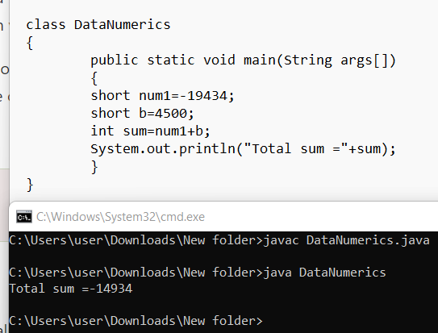

* Long DataType

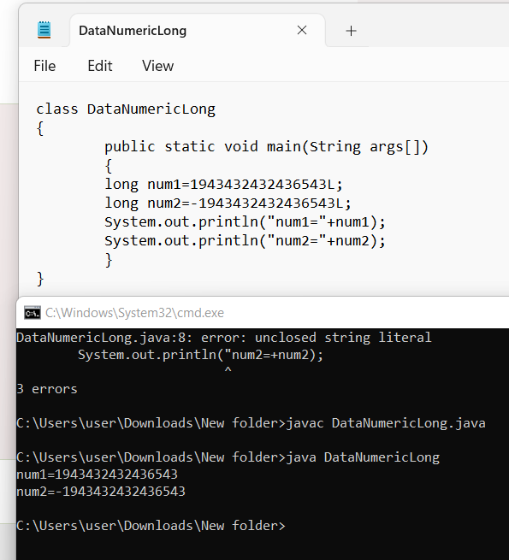

5. Write a program to find the area of a triangle

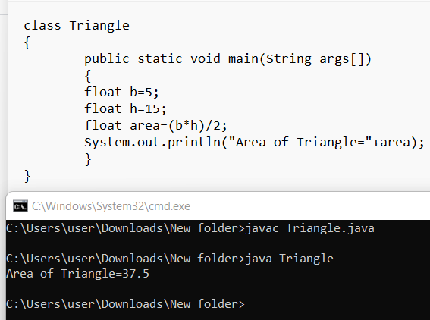

6. Write a program to print name and ph number using data types

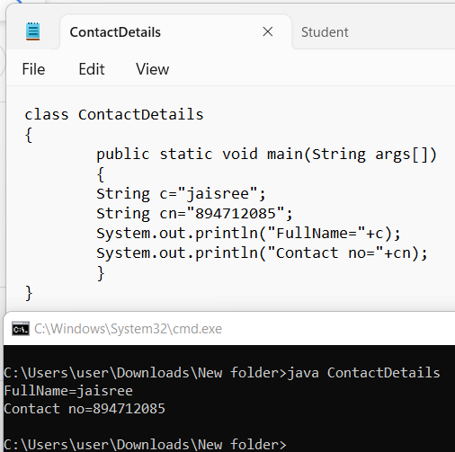

7. Program to

(a) add two numbers

(b) subtract 2 numbers

(c) multiple 2 numbers

(d) divide 2 numbers

